Indian OIL Audit Cost
SL No | Date | Description | Amount
 | 09-03-2025 | Room to Station | 150
 | 09-03-2025 | Water Bottle | 30
 | 09-03-2025 | Dinner | 246.87
 | 09-03-2025 | Jaiput to Dungarpur Ticket | 1318.60
 | 10-03-2025 | Station to Hotel (Cash) | 150
 | 10-03-2025 | Brakefast + Water (Cash) | 140
 | 10-03-2025 | Dinner + Water | 400
 | 11-03-2025 | Brakefast + Water (Cash) | 140
 | 11-03-2025 | Lunch (Cash) | 240
 | 11-03-2025 | Hotel Rent | 4032
 | 11-03-2025 | Hotel to Bus Stand (Cash) | 150
 | 11-03-2025 | Water | 40
 | 11-03-2025 | Dungarpur to Jaipur | 1263
 | 11-03-2025 | Dinner | 230
 | 12-03-2025 | Bus Stand to Room | 210
 | 12-03-2025 | Ticket Cancelation Charge | 90
Total |  |  | 8830.47

09-03-2025
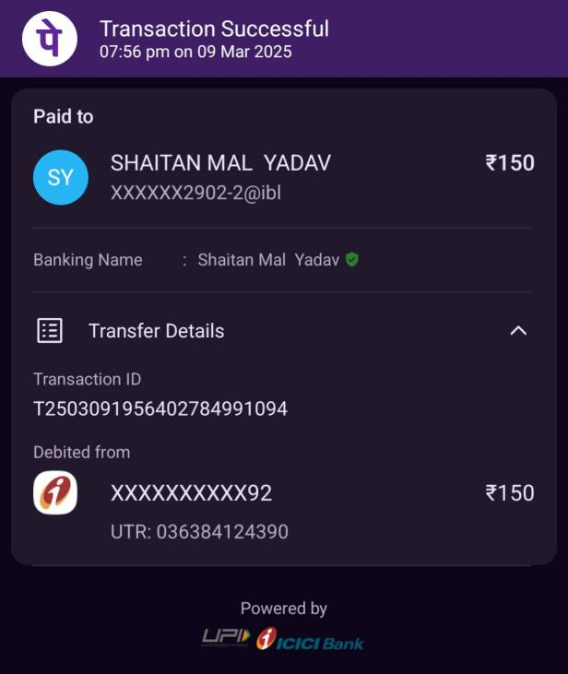 | 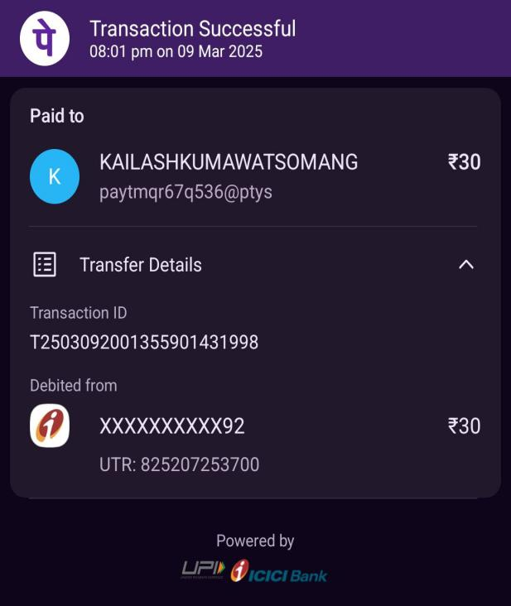
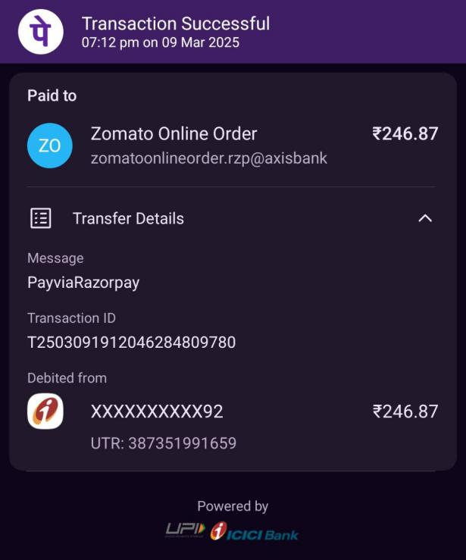
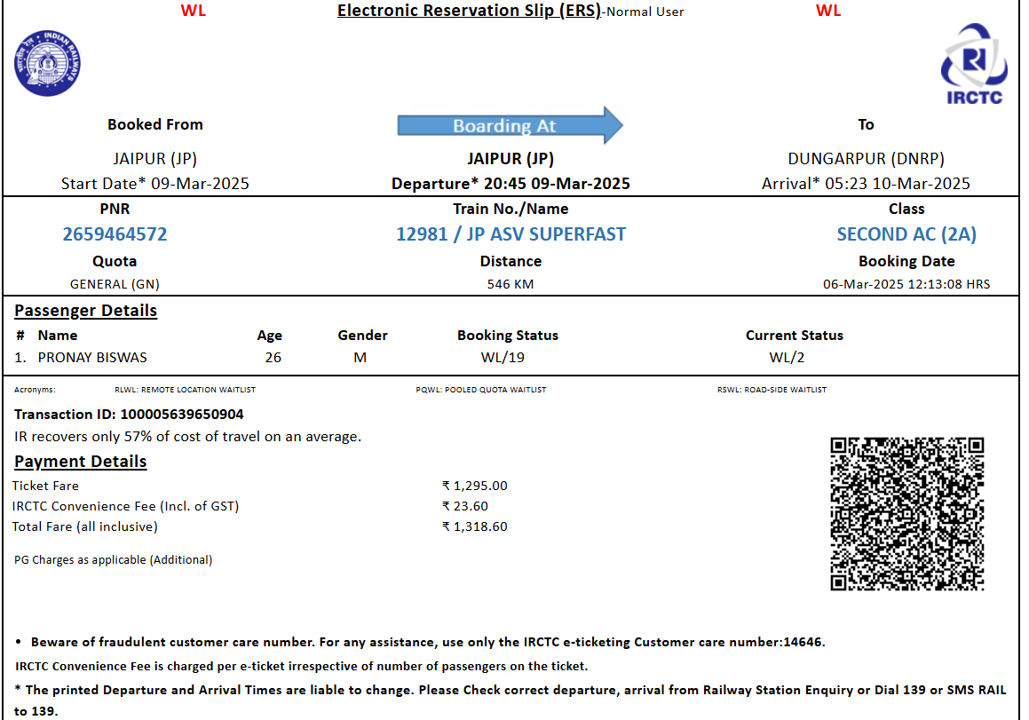
10-03-2025
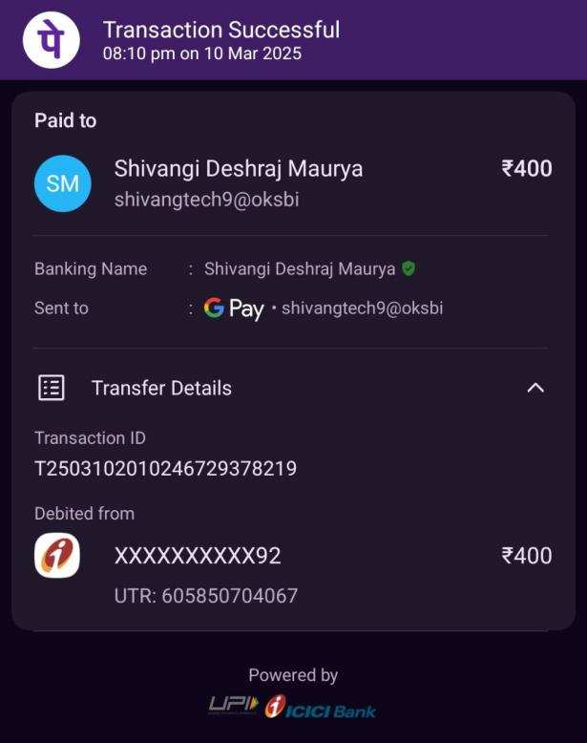
11-01-2025
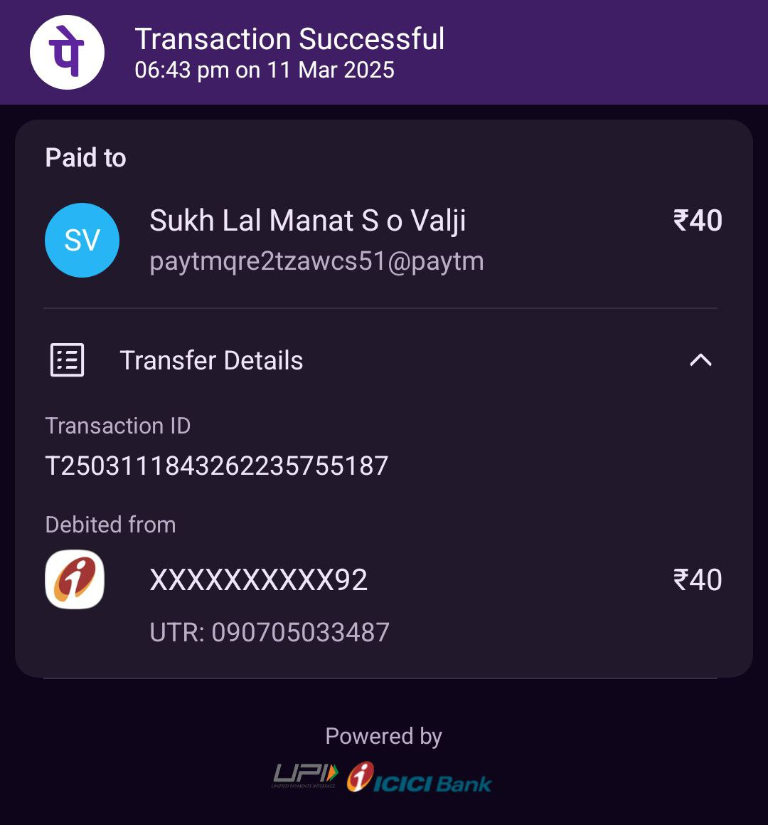
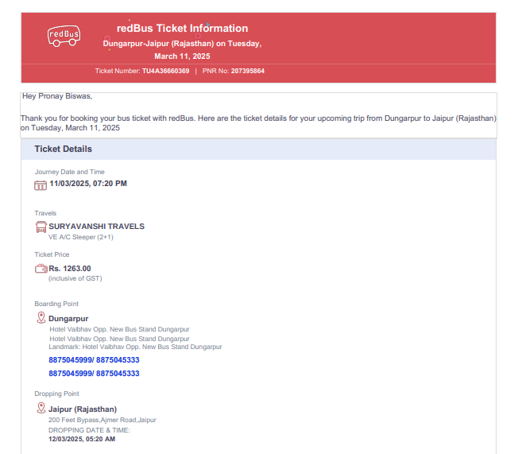
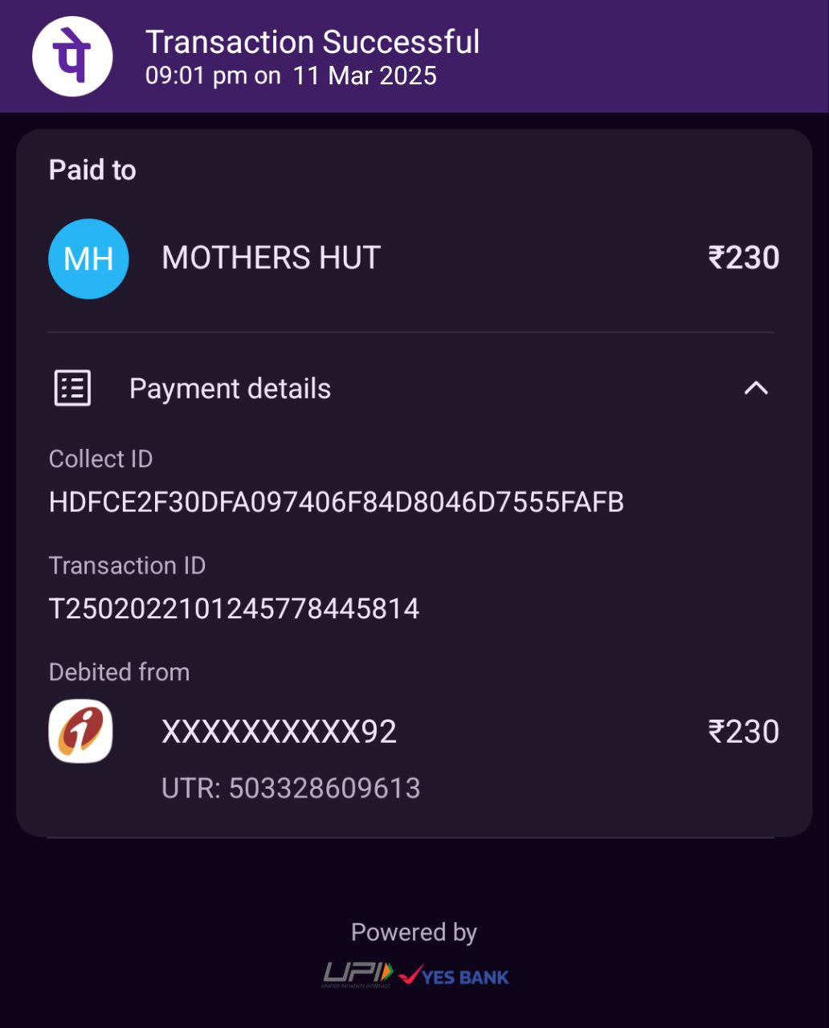
12-01-2025
